


INTERNATIONAL COLLEGE OF BUSINESS AND TECHNOLOGY

CIS6027- Data Visualization Grammar and Idioms
BY
SURAGE SAMPATH DANANJAYA PERIES
CL/BSCDS/CMU/10/58

Cardiff Metropolitan University
B.Sc. (Hons) in Data Science
Assignment Cover Sheet
Student Details ( Student should fill the content)
Name |  | S.S.D.Peries
Student ID |  | CL/BSCDS/CMU/10/58
Scheduled unit details
Unit code |  | CIS6027
Unit title |  | Data Visualization Grammar and Idioms
Unit enrolment details |  | Year |  | 3
 |  | Study period
Lecturer |  | Mr. Roy
Mode of delivery |  | Full Time
Assignment Details
Nature of the Assessment
Topic of the Case Study
Learning Outcomes covered
Word count
Due date / Time |  | 2026-09-02
Extension granted? |  | Yes | No | Extension Date
Is this a resubmission? |  | Yes | No | Resubmission Date
Declaration
I certify that the attached material is my original work. No other person’s work or ideas have been used without acknowledgement. Except where I have clearly stated that I have used some of this material elsewhere, I have not presented it for examination / assessment in any other course or unit at this or any other institution
Name/Signature |  | S.S.D.Peries |  |  | Date |  | 31-08-2026
Submission
Return to:
Result
Marks by 1st  Assessor |  | Name & Signature of the 1st Assessor |  |  |  |  |  | Agreed Mark
Marks by2nd  Assessor |  | Name & Signature of the 2nd Assessor
Comments on
the Agreed mark

Acknowledgement
I would like to express my sincere gratitude to Mr. Roy, lecturer for the module Data Visualization Grammar and Idioms at ICBT Campus, for her valuable guidance, academic support, and feedback throughout this assignment. Her direction contributed significantly to the development of the analytical, visual, and critical approaches adopted in this study.
I also extend my appreciation to Cardiff Metropolitan University for providing the academic framework and learning resources required to complete this research. I acknowledge the contributors of the Steam gaming datasets available through Kaggle, the U.S. Geological Survey (USGS) for the earthquake data used in the comparative visualization analysis, and Valve Corporation for publicly available Steamworks documentation that supported the interpretation of the Steam digital marketplace domain.
Finally, I am grateful to my family and friends for their continued encouragement and support throughout the preparation of this report.

Abstract
This study explores the application of visualization grammar and visual idioms using Steam gaming and global earthquake datasets. It examines visual encoding, semantic layering, multi-grain data, and the risks of misleading aggregation. Two interactive Steam dashboards were developed in Python using Streamlit and Plotly to support both exploratory and explanatory analysis. The study also evaluates emerging technologies such as generative AI, conversational analytics, and immersive AR/VR, highlighting how future visualization systems may become more adaptive, interactive, and decision-oriented while requiring stronger attention to transparency, bias, and analytical accuracy.

Table of Contents
Acknowledgement 3
Abstract 3
Executive Summary 7
Introduction 7
Task 1 - Advanced Grammar and Idioms of Visualization 8
1. Introduction 8
2. Grammar of Graphics and Visual Idioms 8
3. Dataset 1 - Global Major Earthquakes 9
3.1. Idiom-Based Representation: Hexbin Density Map 11
3.2 Grammar-Based Representation: Multichannel Composition 12
4. Dataset 2 - Steam Digital Games Market 13
4.1 Idiom-Based Representation: Genre × Year Heatmap 14
4.2 Grammar-Based Representation: Layered Market Performance 15
5. Expressive Power and Cognitive Accessibility 16
6. Implications for Business Decision-Making 17
Task 2 - Multi-grain Data, Abstraction and Semantic Layering 17
1. Domain Context and Heterogeneous Data 17
2. Grain as the Basis of the Semantic Model 19
3. Semantic Layering from Atomic Data to Strategic KPIs 19
4. Measure Governance and Additivity 21
5. Many to Many Genres and Semantic Integrity 23
6. Visual Grammar and Idioms Across Semantic Layers 25
7. Critical Review of Grain Misalignment 25
8. Conclusion 26
Task 3 - Designing Idiomatic, Multi-Perspective Dashboards 27
1. Introduction 27
2. Dataset and Analytical Structure 27
3. Dashboard 1 - Exploratory Explorer 28
3.1 Analytical Purpose and Interaction Design 28
3.2 KPI Summary Layer 28
3.3 Temporal Trajectory: Releases by Genre 29
3.4 Commercial Matrix: Price and Positivity 29
3.5 Year × Genre Positivity Heatmap 30
3.6 Publisher Genre Platform Network 31
3.7 Filtering and What-if Analysis 31
4. Dashboard 2 - Explanatory Story 32
4.1 Narrative Purpose 32
4.2 Stage 1 - Supply Expansion Over Time 32
4.3 Stage 2 - Market Structure Treemap 33
4.4 Stage 3 - Small-Sample Rating Effects 34
4.5 Stage 4 - Global Studio Production 34
5. Critical Evaluation of the Dashboard System 34
6. Conclusion 35
Task 4 - Future of Visualisation Idioms with Emerging Technologies 35
1. Introduction 35
2. Generative AI and Conversational Visualisation 36
3. Immersive Analytics, AR/VR and Digital Environments 36
4. Hypothetical Steam Market Analytics Scenario 37
5. Ethical and Cognitive Risks 38
5.1 Hallucination and Analytical Reliability 38
5.2 Hidden Semantic Assumptions 38
5.3 Automation Bias 38
5.4 Immersive Bias and Privacy 38
6. Evolution of Visualisation Grammar and Idioms (2026-2036) 39
7. Conclusion 39
Conclusion 40
References 40

Table of Figures
Figure 1Dataset 1 - Code Block - 1 11
Figure 2Dataset 1 - Code Block - 2 11
Figure 3Hexbin representation of major earthquake distribution 12
Figure 4Dataset 1 - Code Block -3 12
Figure 5Grammar-Based Multichannel Earthquake Visualisation 13
Figure 6 Dataset 1 - Code Block -4 14
Figure 7 Steam Genre × Release-Year Satisfaction Heatmap 15
Figure 8 Dataset 2 - Code Block -5 16
Figure 9 Grammar-Based Steam Market Performance Visualisation 17
Figure 10 Dataset 2 - Code Block -6 17
Figure 11 Task 2 - Code Block 1 20
Figure 12 code block 2 21
Figure 13 code block 3 23
Figure 14 code block 4 24
Figure 15 code block 5-1 25
Figure 16 code block 5-2 26
Figure 17 Visual 5 27
Figure 18 Dashboard 1 30
Figure 19 Dashboard 1 - Figure 1 31
Figure 20 Dashboard 1 - Figure 2 32
Figure 27 Dashboard 2 - Figure4 38

Executive Summary
This report evaluates how visualization grammar, visual idioms, semantic data structures, and interactive dashboards can support more effective business analysis. Using Steam marketplace data and global earthquake data, the study demonstrates how different visual encodings can reveal or obscure important patterns. A multi-grain semantic model was developed to preserve analytical meaning across raw data, aggregates, and KPIs. Two Steam dashboards were then created: an exploratory dashboard for filtering, comparison, and network analysis, and an explanatory dashboard for guided storytelling. The report concludes that effective visualization depends on aligning data grain, semantic meaning, visual encoding, and decision context, while emerging AI and immersive technologies introduce both new analytical opportunities and new risks.

Introduction
This study investigates the principles and practical application of data visualization grammar and idioms across complex multidimensional datasets. The analysis uses the Steam digital gaming marketplace as the primary business domain, supported by a global earthquake dataset to compare grammar-driven and idiom-driven representations.
The report examines how data attributes are mapped to visual channels, how structured, semi-structured, and unstructured data can be integrated through semantic layering, and how changes in data grain can influence analytical interpretation. It also presents two complementary Steam dashboards: an exploratory dashboard supporting filtering, comparison, network analysis, and interactive investigation, and an explanatory dashboard designed to communicate a guided market narrative through annotated and idiomatic visualizations.
Finally, the study evaluates emerging technologies including generative AI, conversational visualization, and immersive AR/VR analytics, considering how they may reshape visualization

Task 1 - Advanced Grammar and Idioms of Visualization

Introduction
Data visualisation can be examined through two complementary concepts the grammar of graphics and visual idioms. The grammar of graphics provides a structured method for combining data, transformations, marks, scales and visual channels to construct visual representations (Wilkinson, 2005). This compositional approach was further developed through layered grammar (Wickham, 2010) and later incorporated into declarative systems such as Vega-Lite (Satyanarayan, 2017). Its emphasis is on selecting visual encodings according to data characteristics and analytical objectives rather than relying on predefined chart types.
Visual idioms, in contrast, are familiar graphical structures designed for particular analytical tasks, including heatmaps, timelines and treemaps (Munzner, 2014). Although conceptually distinct, idioms can be constructed using grammatical principles. Their relationship therefore reflects a balance between flexibility and interpretability. This study evaluates that balance using earthquake and Steam marketplace datasets, comparing idiom-based and grammar-oriented representations in terms of encoding, perception and decision support.

2. Grammar of Graphics and Visual Idioms
A grammar-based approach treats visualisation as the deliberate combination of data, transformations, graphical marks, visual channels, scales, coordinate systems and interaction. Frameworks such as Vega-Lite operationalise these elements through declarative specifications, allowing analysts to construct representations according to the analytical problem rather than selecting a chart type in advance.
This flexibility is particularly useful for multidimensional data because variables can be assigned to different visual channels according to their analytical importance. Visual idioms, in contrast, use established structures such as heatmaps, timelines and treemaps. Their familiarity can reduce interpretation effort, although they may also limit the amount of information that can be represented without increasing complexity.

Dimension | Visualisation Grammar | Visual Idioms
Design principle | Composition of graphical elements | Established graphical structure
Examples | ggplot2, Vega-Lite | Heatmap, treemap, hexbin map
Flexibility | High | More constrained
Main benefit | Supports multidimensional encoding | Supports rapid interpretation
Main limitation | Potential cognitive overload | Potential information loss

The effectiveness of both approaches depends on perceptual principles. (Cleveland, 1984) found that quantitative comparisons based on aligned position are generally more accurate than those based on area or angle, suggesting that important measures should use more precise channels. Colour also requires semantic consistency, as viewers often associate greater intensity or darkness with larger quantities (Soto, 2023). Visual encoding should therefore reflect both data structure and perceptual expectations.

3. Dataset 1 - Global Major Earthquakes
The earthquake dataset contains records of events with magnitudes of 6 or greater between 1900 and 2023. Its variables include location, magnitude, focal depth and other seismic measures, creating a combination of spatial, temporal and quantitative information (Mexwell, n.d.).
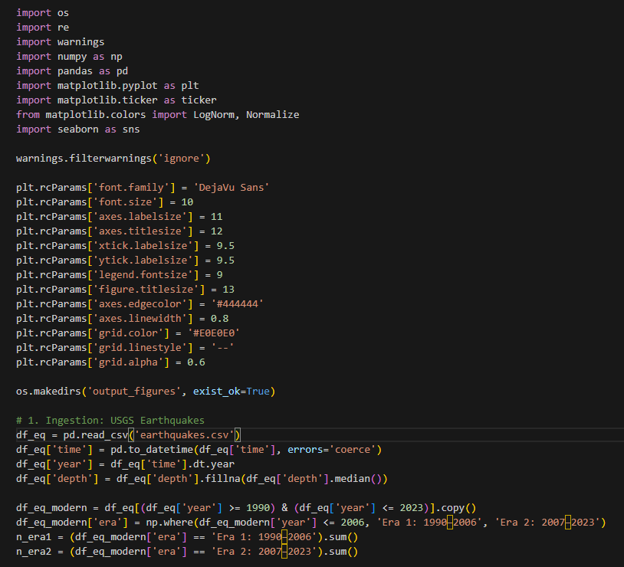
Figure 1Dataset 1 - Code Block - 1
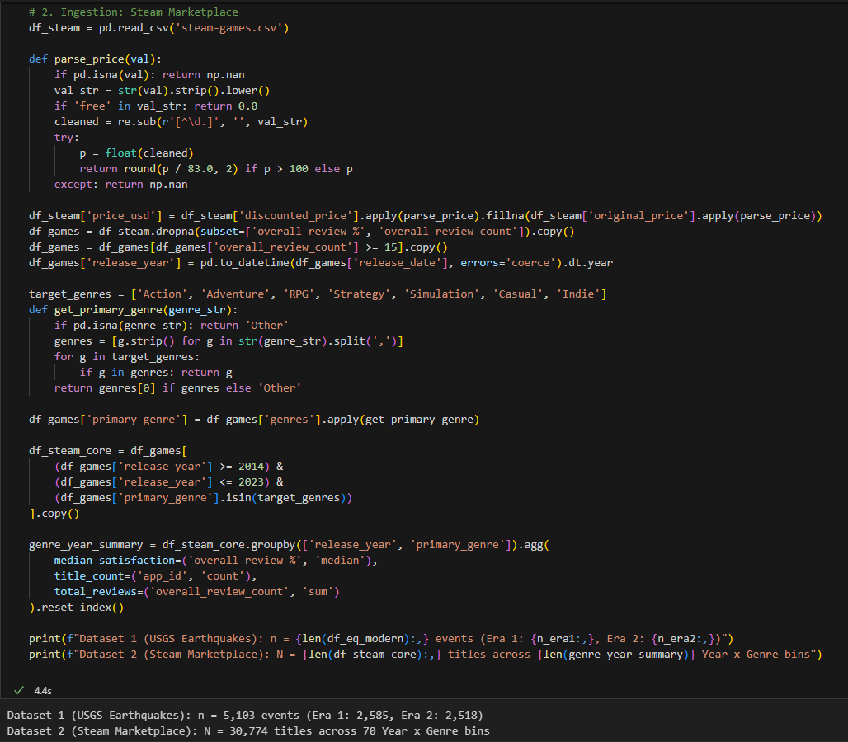
Figure 2Dataset 1 - Code Block - 2

3.1. Idiom-Based Representation: Hexbin Density Map
A hexbin density map summarises earthquake distribution by aggregating events into geographic hexagons based on longitude and latitude, with colour intensity representing event frequency. This reduces point overlap and makes broad spatial concentrations easier to identify, which is useful when the analytical focus is the geographic pattern of seismic activity.
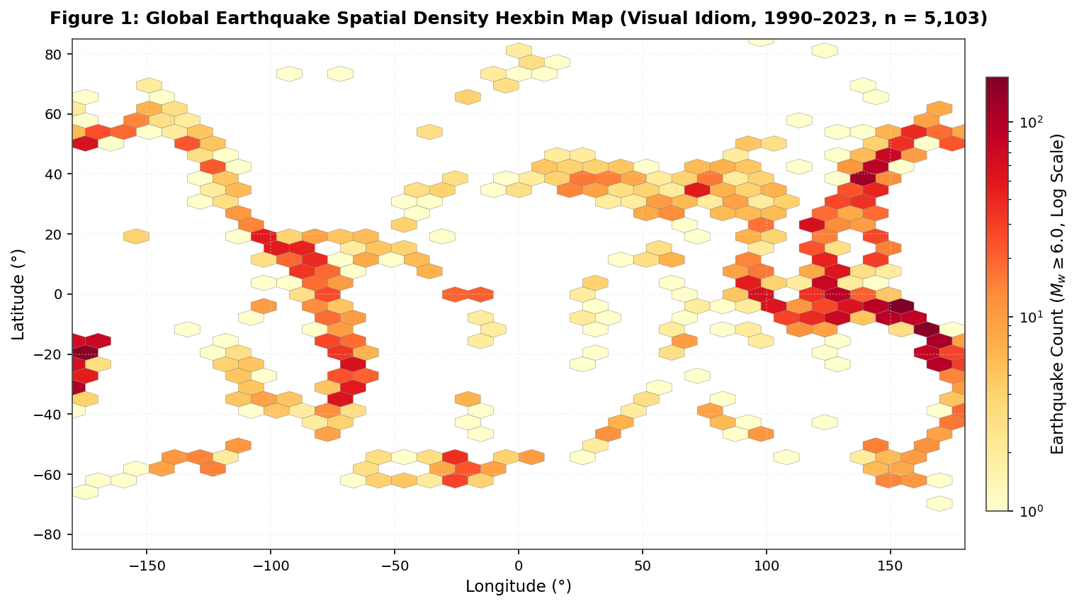
Figure 3Hexbin representation of major earthquake distribution
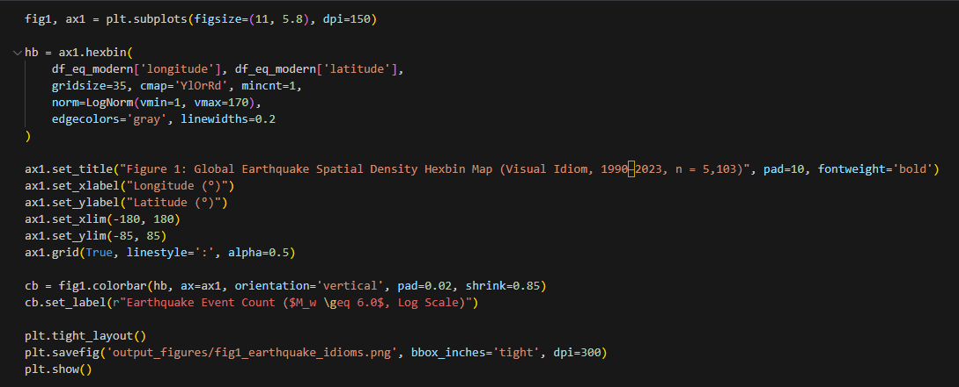
Figure 4Dataset 1 - Code Block -3
However, aggregation also removes event-level characteristics such as magnitude and depth. Regions with similar earthquake counts may therefore differ substantially in severity. This limitation is important because earthquake magnitude is logarithmic; a one-unit increase represents roughly a tenfold increase in measured amplitude, with a larger increase in energy release (U.S. Geological Survey (USGS), 2026)The map is therefore effective for identifying concentration, but should not be interpreted as a direct representation of seismic severity.

3.2 Grammar-Based Representation: Multichannel Composition
A grammar-based representation preserves more event-level information by assigning variables to distinct visual channels. Geographic position represents longitude and latitude, point size indicates earthquake magnitude, colour encodes focal depth, and faceting separates temporal periods. This allows several dimensions of seismic activity to be examined within the same analytical view.
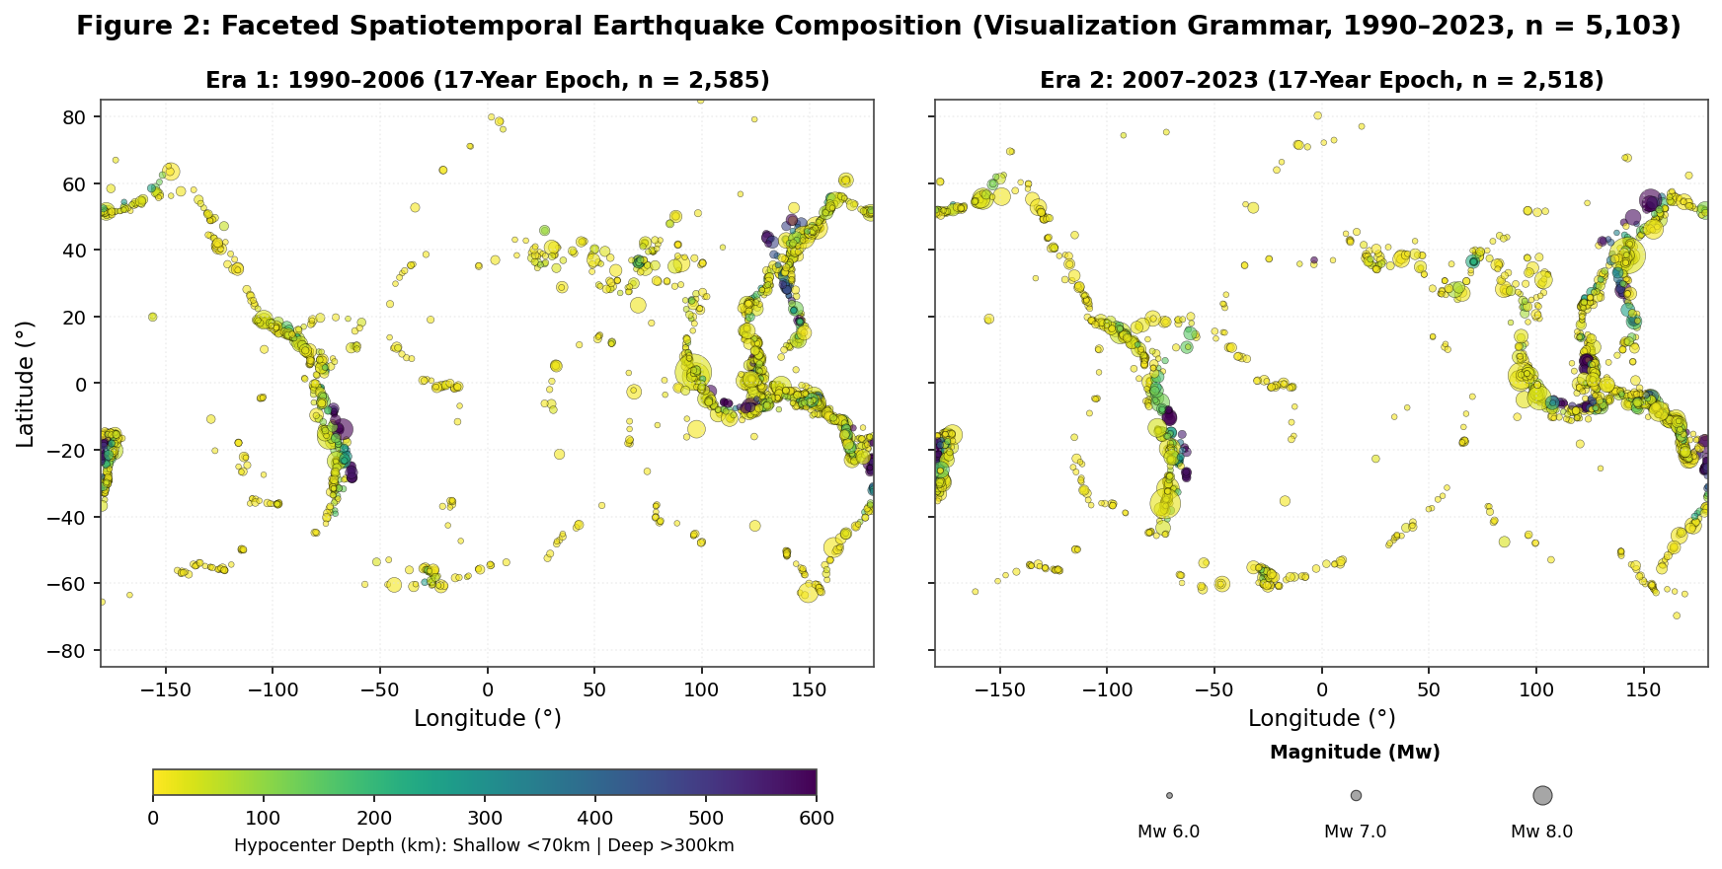
Figure 5Grammar-Based Multichannel Earthquake Visualisation
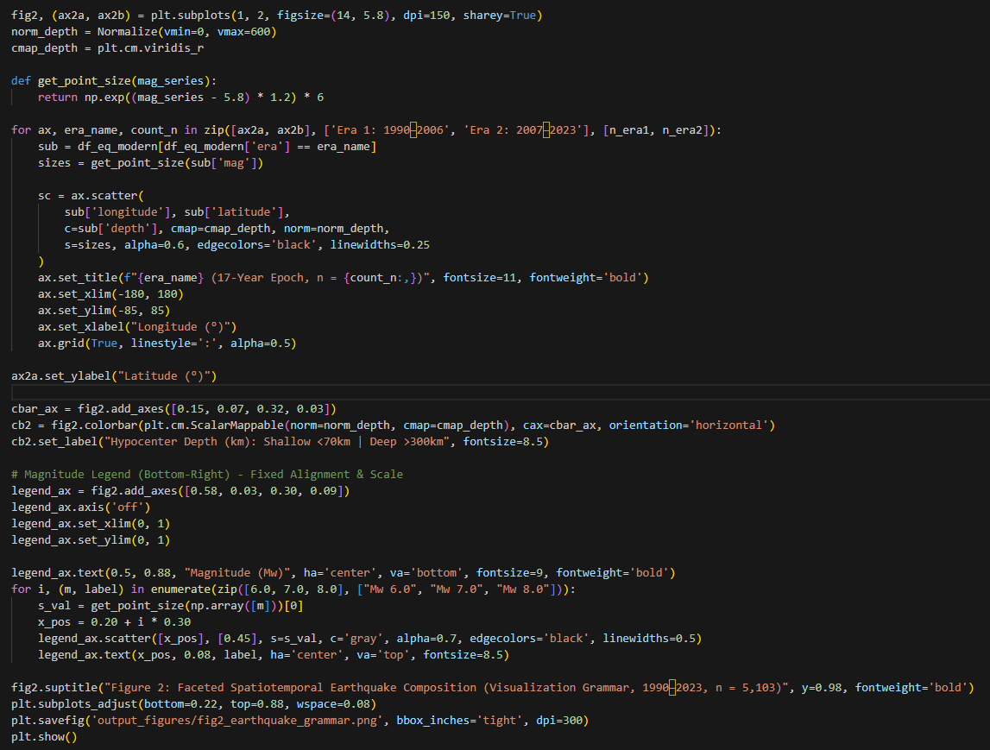
Figure 6 Dataset 1 - Code Block -4
Unlike the density map, this approach retains individual earthquakes and supports comparison of location, magnitude, depth and time simultaneously. It can therefore distinguish regions dominated by frequent moderate events from those containing fewer but stronger earthquakes. However, the additional encodings increase interpretation demands. The effectiveness of the design depends on whether each visual channel contributes directly to the analytical objective rather than adding unnecessary complexity.

4. Dataset 2 - Steam Digital Games Market
The Steam dataset includes variables such as genre, release date, review outcomes, playtime, estimated ownership and price (Huynh, n.d.). Market performance can be examined through a derived satisfaction measure,
$$Player Satisfaction (\%)=\frac{Positive Reviews}{Positive Reviews+Negative Reviews}×100$$

4.1 Idiom-Based Representation: Genre × Year Heatmap
A heatmap can summarise Steam market performance by mapping release year to the horizontal axis, genre to the vertical axis and median satisfaction to colour intensity. This structure supports rapid comparison across categories and time periods because viewers can identify broad patterns without decoding several visual channels simultaneously.
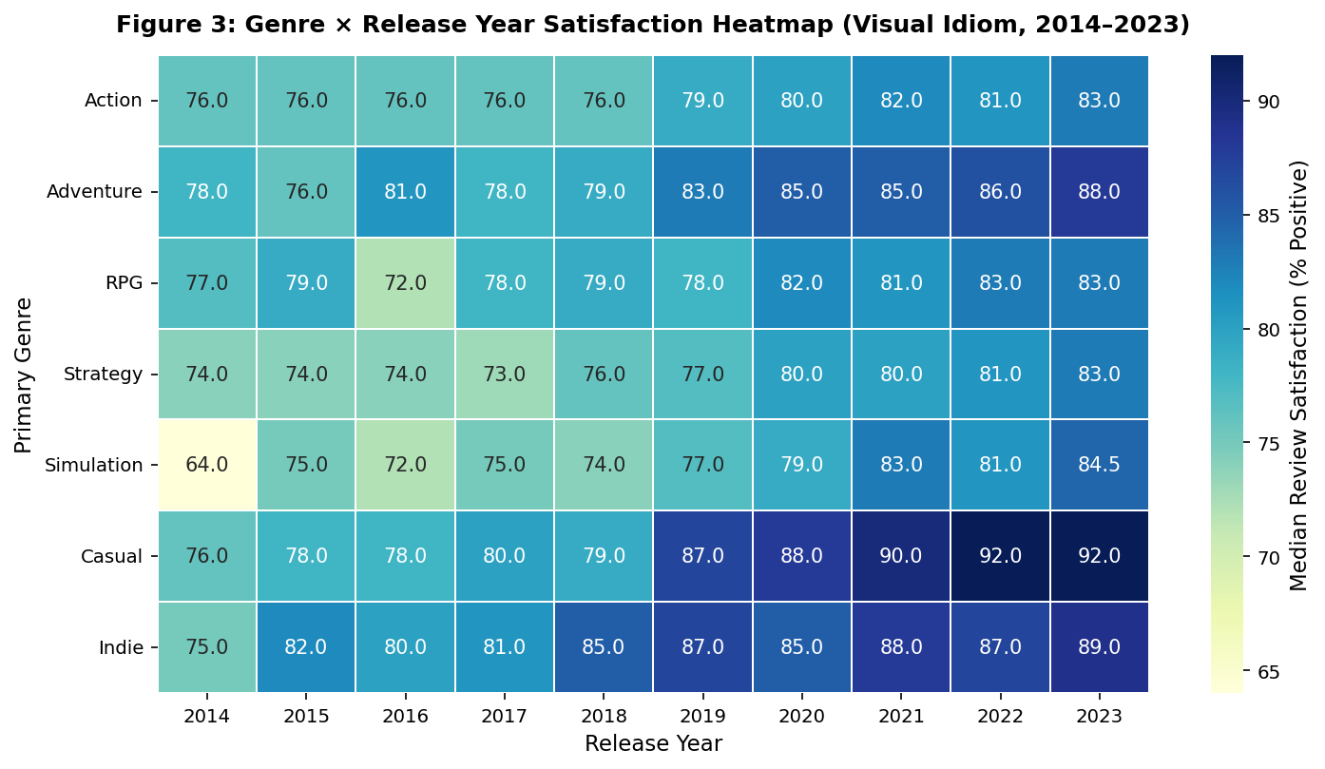
Figure 7 Steam Genre × Release-Year Satisfaction Heatmap
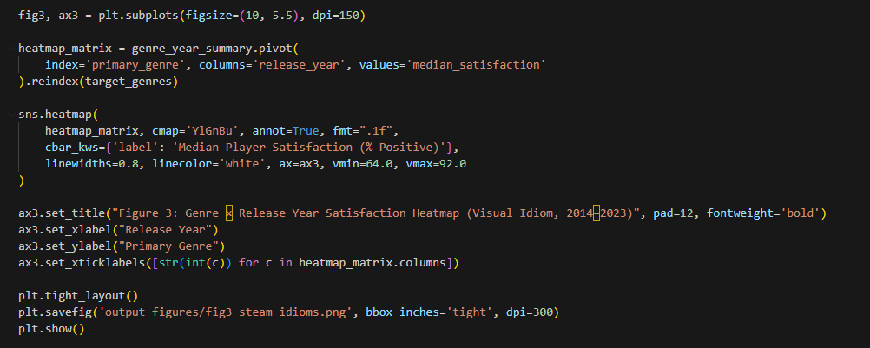
Figure 8 Dataset 2 - Code Block -5
Its main limitation is the absence of market volume. Each year-genre cell occupies the same visual area regardless of how many titles it represents, meaning that a small niche category may appear comparable to a much larger segment if both show similar satisfaction levels. The issue is therefore one of contextual completeness rather than statistical error. For strategic decisions, satisfaction should be interpreted alongside the scale of the underlying market, as the heatmap alone may conceal differences in release volume and commercial significance.

4.2 Grammar-Based Representation: Layered Market Performance
A layered grammar can represent the same Steam data by mapping release year to horizontal position, median satisfaction to vertical position, genre to colour and title count to point size, while connecting lines indicate temporal continuity. This structure places the main quantitative measure on aligned position, which supports more accurate comparison than colour or area (Cleveland, 1984).
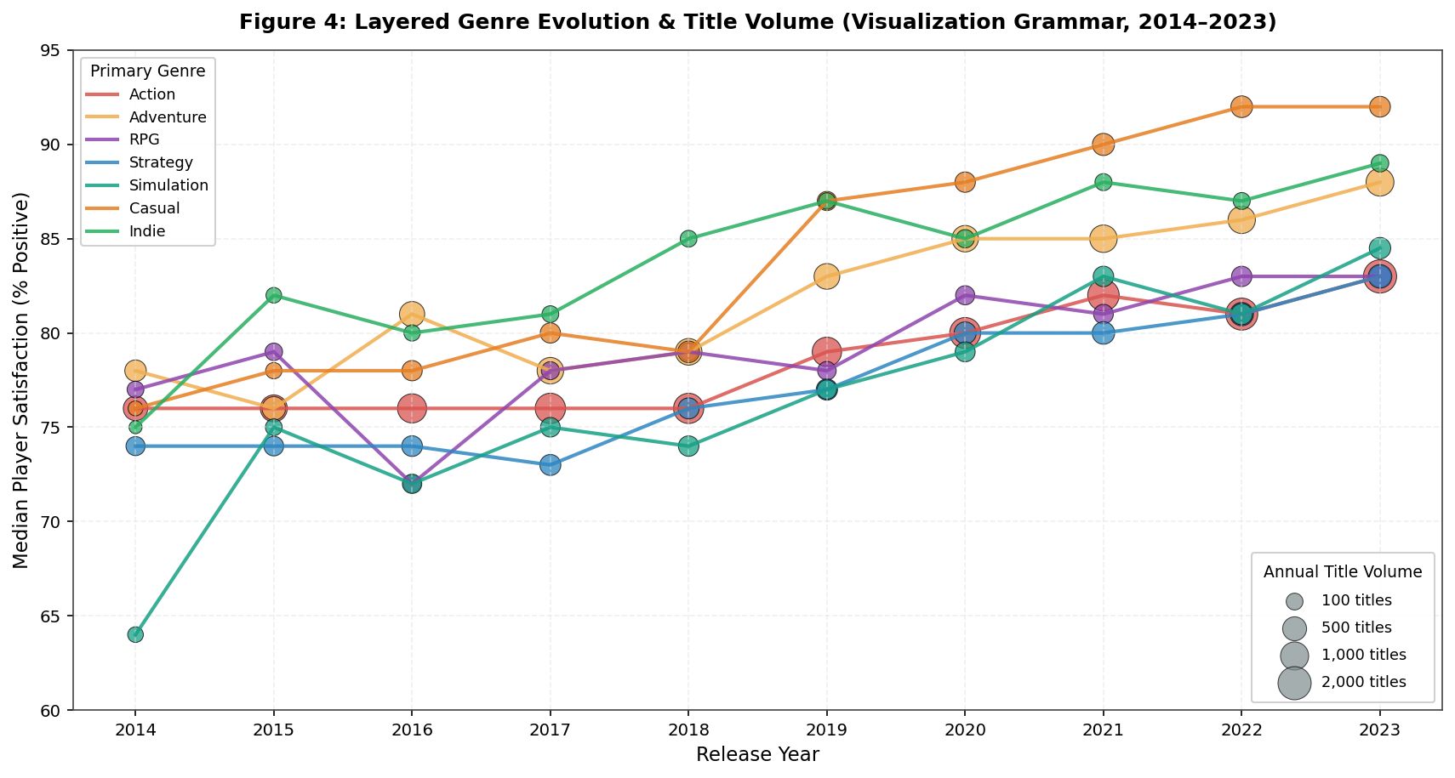
Figure 9 Grammar-Based Steam Market Performance Visualisation
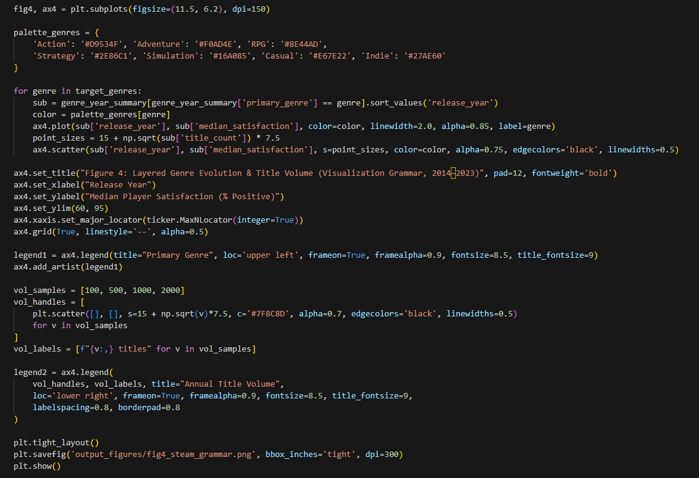
Figure 10 Dataset 2 - Code Block -6
The design also introduces market volume as a secondary measure. This makes it possible to distinguish genres with high satisfaction but limited release activity from those with slightly lower satisfaction and substantially greater market presence. Compared with the heatmap, the layered view therefore provides a broader basis for assessing commercial significance by combining performance, category identity and market scale within the same representation.

5. Expressive Power and Cognitive Accessibility
Grammar and visual idioms support different aspects of analytical communication. Grammar offers greater flexibility by combining multiple variables through position, colour, size, layering and faceting, but additional encodings can increase cognitive demand without necessarily improving interpretation. In contrast, familiar idioms such as heatmaps and density maps reduce this burden because viewers can rely on established visual conventions.
However, simplicity can also remove important context. Aggregation may conceal sample size, event-level variation or secondary variables that influence interpretation. (Hjelle, 2024) show that both information structure and completeness can affect perceived complexity and decision quality. Therefore, neither highly complex nor highly simplified visualisations are inherently preferable. A more effective approach is to combine both strategies: idioms can provide accessible overviews, while grammar-based layering, faceting or interaction can introduce additional detail when required by the analytical objective.

6. Implications for Business Decision-Making
Visualisation design can shape business judgement because choices in aggregation, scaling and encoding influence which patterns receive attention. In the Steam heatmap, a niche genre with high satisfaction may appear commercially attractive even when it represents a small number of releases. The issue is therefore not incorrect calculation, but the omission of market context.
A similar problem occurs in earthquake analysis, where event frequency may be interpreted as risk despite differences in magnitude. This creates a frequency severity bias by giving visual prominence to count rather than consequence. Colour mappings can also affect interpretation when they conflict with expected meaning (Soto, 2023), while inconsistent scales or manipulated axes may further distort judgement (Rho, 2024). Excessive use of size, colour, opacity and shape can introduce additional competition for attention. Effective visualisation therefore requires each encoding to be justified by its analytical relevance rather than by the amount of information it can display.

Task 2 - Multi-grain Data, Abstraction and Semantic Layering

1. Domain Context and Heterogeneous Data
The Steam digital marketplace provides an appropriate context for multi-grain analysis because its data originate from different operational processes and exist at varying levels of detail. The cleaned dataset includes attributes such as title, developer, genre, release date, ratings, playtime, ownership estimates and price (Huynh, n.d.). These records can be supplemented by Steamworks and review-service data covering ownership, achievements, player activity, transactions and written feedback, creating a heterogeneous analytical environment (Valve Corporation, n.d.).
These sources can be grouped into three broad data modalities.

Data type | Steam-domain examples | Typical grain | Analytical role
Structured | App ID, price, release date, ratings, playtime, achievements | One application snapshot, review or event | Aggregation, benchmarking and temporal analysis
Semi-structured | API JSON, genres, categories, tags and achievement objects | One response or entity containing nested relationships | Metadata integration and many-to-many analysis
Unstructured | Player reviews and developer responses | One textual record | Sentiment, topic and complaint analysis

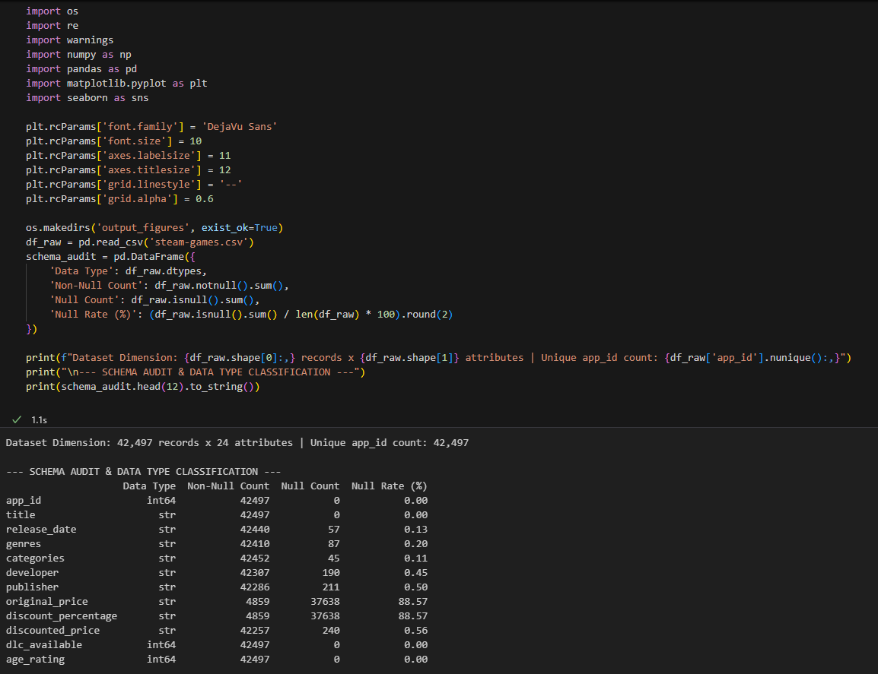
Figure 11 Task 2 - Code Block 1
These data modalities should remain distinct because combining different grains can distort analysis. Derived review measures, such as sentiment or topic scores, should remain traceable to the original text. Since sentiment analysis is sensitive to context, negation and ambiguity, numerical scores should be treated as abstractions rather than complete representations of user feedback (Wankhade, 2022).

2. Grain as the Basis of the Semantic Model
Defining grain before aggregation is essential in multidimensional analysis because each fact must represent a consistent level of detail (microsoft, 2024). For the cleaned Steam dataset, the atomic grain can be defined as one Steam application at a specific observation snapshot. This should remain distinct from purchases, reviews and engagement events, which would require separate fact structures.
Incorrect grain definitions can distort measures. For example, cumulative review totals of 10,000, 12,000 and 15,000 across three months should not be summed to 37,000. The latest stock is 15,000, while the net increase is 5,000. Accurate aggregation therefore depends not only on the calculation applied, but also on understanding the temporal behaviour and analytical grain of each measure.
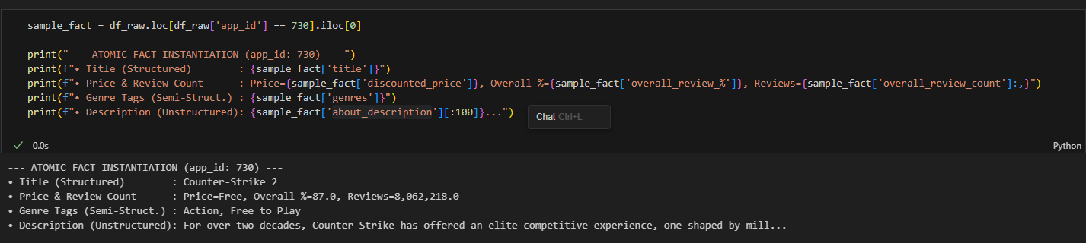
Figure 12 code block 2

3. Semantic Layering from Atomic Data to Strategic KPIs
A useful semantic architecture should extend beyond a simple progression from raw data to aggregate metrics. For the Steam domain, a five-layer model can support clearer separation between source preservation, data conformity, analytical derivation and business interpretation.

Layer | Grain | Semantic purpose | Examples
L0 - Source | Original CSV, API or text | Preserve provenance | Game record, review JSON
L1 - Conformed atomic facts | One AppID, review or event | Standardise entities and relationships | Price, release date, review counts
L2 - Derived semantic measures | Primarily one AppID | Create reusable business measures | Satisfaction, review volume, price band
L3 - Analytical aggregates | Year × Genre, Developer × Year | Compare groups and identify patterns | Title count, median satisfaction
L4 - Strategic KPIs | Segment, market or period | Support management decisions | Genre growth, review positivity, engagement

At L0, information is retained in its source form so that lineage and auditability are preserved. At L1, identifiers, dates, developers, publishers, genres and platforms are standardised into conformed analytical entities. This reflects the purpose of modern semantic models, which aim to provide consistent business terminology, relationships and reusable measures independently of the physical storage layer (Microsoft, 2026).
At L2, reusable measures are created. For example:
$$ReviewVolume_{i}=Positive_{i}+Negative_{i}$$
and:
$$Satisfaction_{i}=\frac{Positive_{i}}{Positive_{i}+Negative_{i}}×100$$
Other transformations may include deriving release year from release date or grouping price into documented bands. Such operations should remain explicit because semantic meaning depends on how transformations are defined. This principle is comparable to declarative visualisation grammars such as Vega-Lite, where calculated fields, filters, transformations and aggregations are stated before graphical encoding (Vega-Lite, 2026).
At L3, observations can be aggregated to controlled analytical grains such as:
$$ReleaseYear×PrimaryGenre$$
This level may contain measures such as distinct title count, median game satisfaction, review volume and median price. At L4, these aggregates are converted into governed KPIs, including genre growth, portfolio performance, market concentration and platform-level review positivity.
The architecture should also preserve the ability to move from summary measures back toward evidence:
$$KPI→Aggregate→Game→Atomic Evidence$$
Maintaining this reversibility reduces the risk that dashboards become detached from the records on which their conclusions depend.
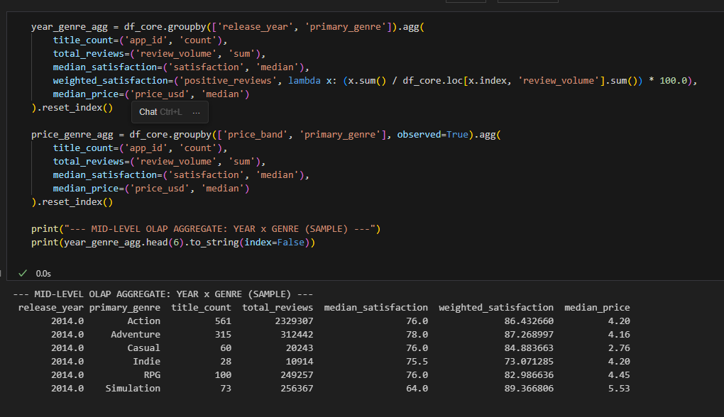
Figure 13 code block 3

4. Measure Governance and Additivity
A semantic layer must also define how individual measures may be aggregated. Review counts may be additive across distinct games at the same observation point, but cumulative review snapshots should not be summed across time. Measures such as price, satisfaction and playtime are generally non-additive and need to be recalculated according to the grain of analysis.
Satisfaction provides an important example. The average satisfaction across games can be expressed as:
$$\overline{S}=\frac{1}{n}\sum_{i=1}^{n}{\frac{P_{i}}{P_{i}+N_{i}}}$$
By contrast, the proportion of all observed reviews that are positive is:
$$S_{reviews}=\frac{\sum_{i}{P_{i}}}{\sum_{i}{(}\left.P_{i}+N_{i}\right)}$$
Although both statistics may be described informally as satisfaction, they represent different analytical perspectives. The first gives equal weight to each game and therefore describes the average game-level satisfaction rate. The second gives weight according to review volume and therefore reflect the proportion of positive reviews across the full set of observations.
The risk arises when one measure is labelled as though it represented the other. Because semantic models centralise reusable business metrics, their value depends on making these weighting assumptions explicit. Microsoft (2026) similarly emphasises consistency and accuracy in business metric definitions as a basis for reliable decision-making.
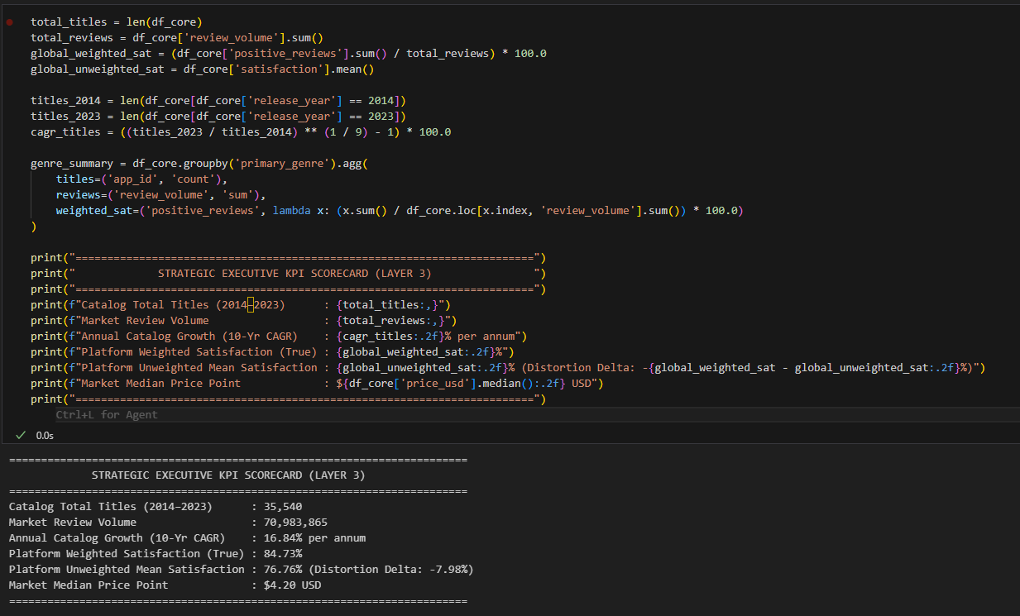
Figure 14 code block 4

5. Many to Many Genres and Semantic Integrity
Steam titles may belong to several genres simultaneously, creating a many-to-many relationship between games and categories. Keeping genres within a single field preserves the one-row-per-game grain but restricts category analysis, while expanding genres into separate rows changes the grain to one game–genre relationship per row.
A more reliable design separates this structure through ‘DimGame’, ‘DimGenre’ and ‘BridgeGameGenre’, with the bridge storing each valid association (Microsoft, 2025). This avoids treating duplicated genre rows as independent game facts. (Pedersen, 2001) similarly identify varying granularity and non-strict relationships as key multidimensional modelling issues. Thus, 90,000 genre memberships derived from 35,000 games may both be valid counts, the error occurs only when membership records are interpreted as unique games.
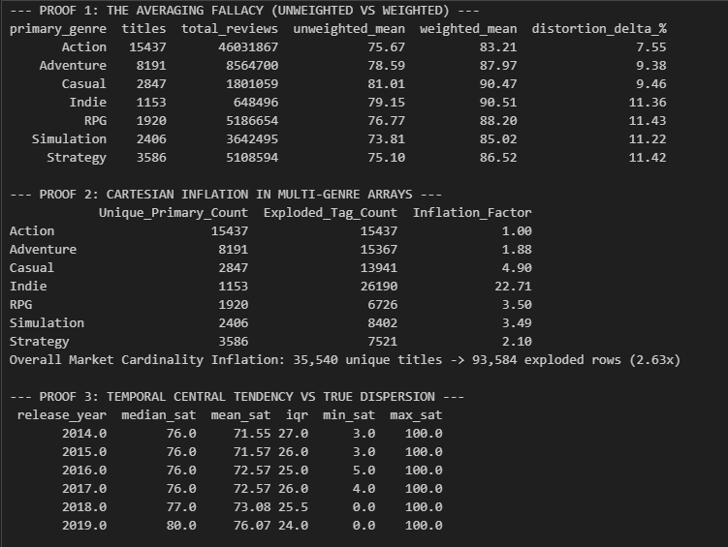
Figure 15 code block 5-1
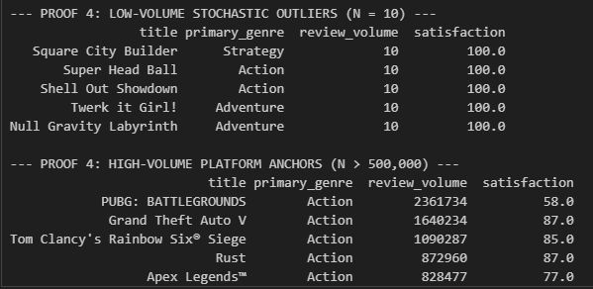
Figure 16 code block 5-2

6. Visual Grammar and Idioms Across Semantic Layers
Visual representation should reflect the grain of analysis because different abstraction levels support different decisions. At the atomic game level, scatterplots and distributional views preserve individual observations and can encode review volume, satisfaction, genre and evidence strength through position, colour and size.
At the Year × Genre level, heatmaps or layered line-point charts are more suitable because they summarise patterns across categories and time. Declarative systems such as Vega-Lite support these transformations and encodings explicitly (Satyanarayan, 2017). At the strategic KPI level, simpler forms such as KPI cards, trends and target comparisons are more appropriate because executives require concise decision-oriented information. (Hjelle, 2024) show that dashboard structure and information completeness influence perceived complexity and decision quality. Therefore, visual complexity should match the analytical grain and decision context.

7. Critical Review of Grain Misalignment
Grain misalignment can produce several analytical errors. One concerns the difference between the mean of ratios and the ratio of sums. If one game records 9 positive reviews from 10 and another records 7,000 from 10,000, the average game-level satisfaction is 80%, whereas review-weighted satisfaction is approximately 70%. Both are valid, but they answer different questions and should not be interpreted interchangeably.
The interactive Steam Market Visual Intelligence Suite developed for this study is deployed and publicly hosted on Streamlit Community Cloud at Steam Market Visual Analytics (https://steam-games-analytics-dashboard.streamlit.app/).
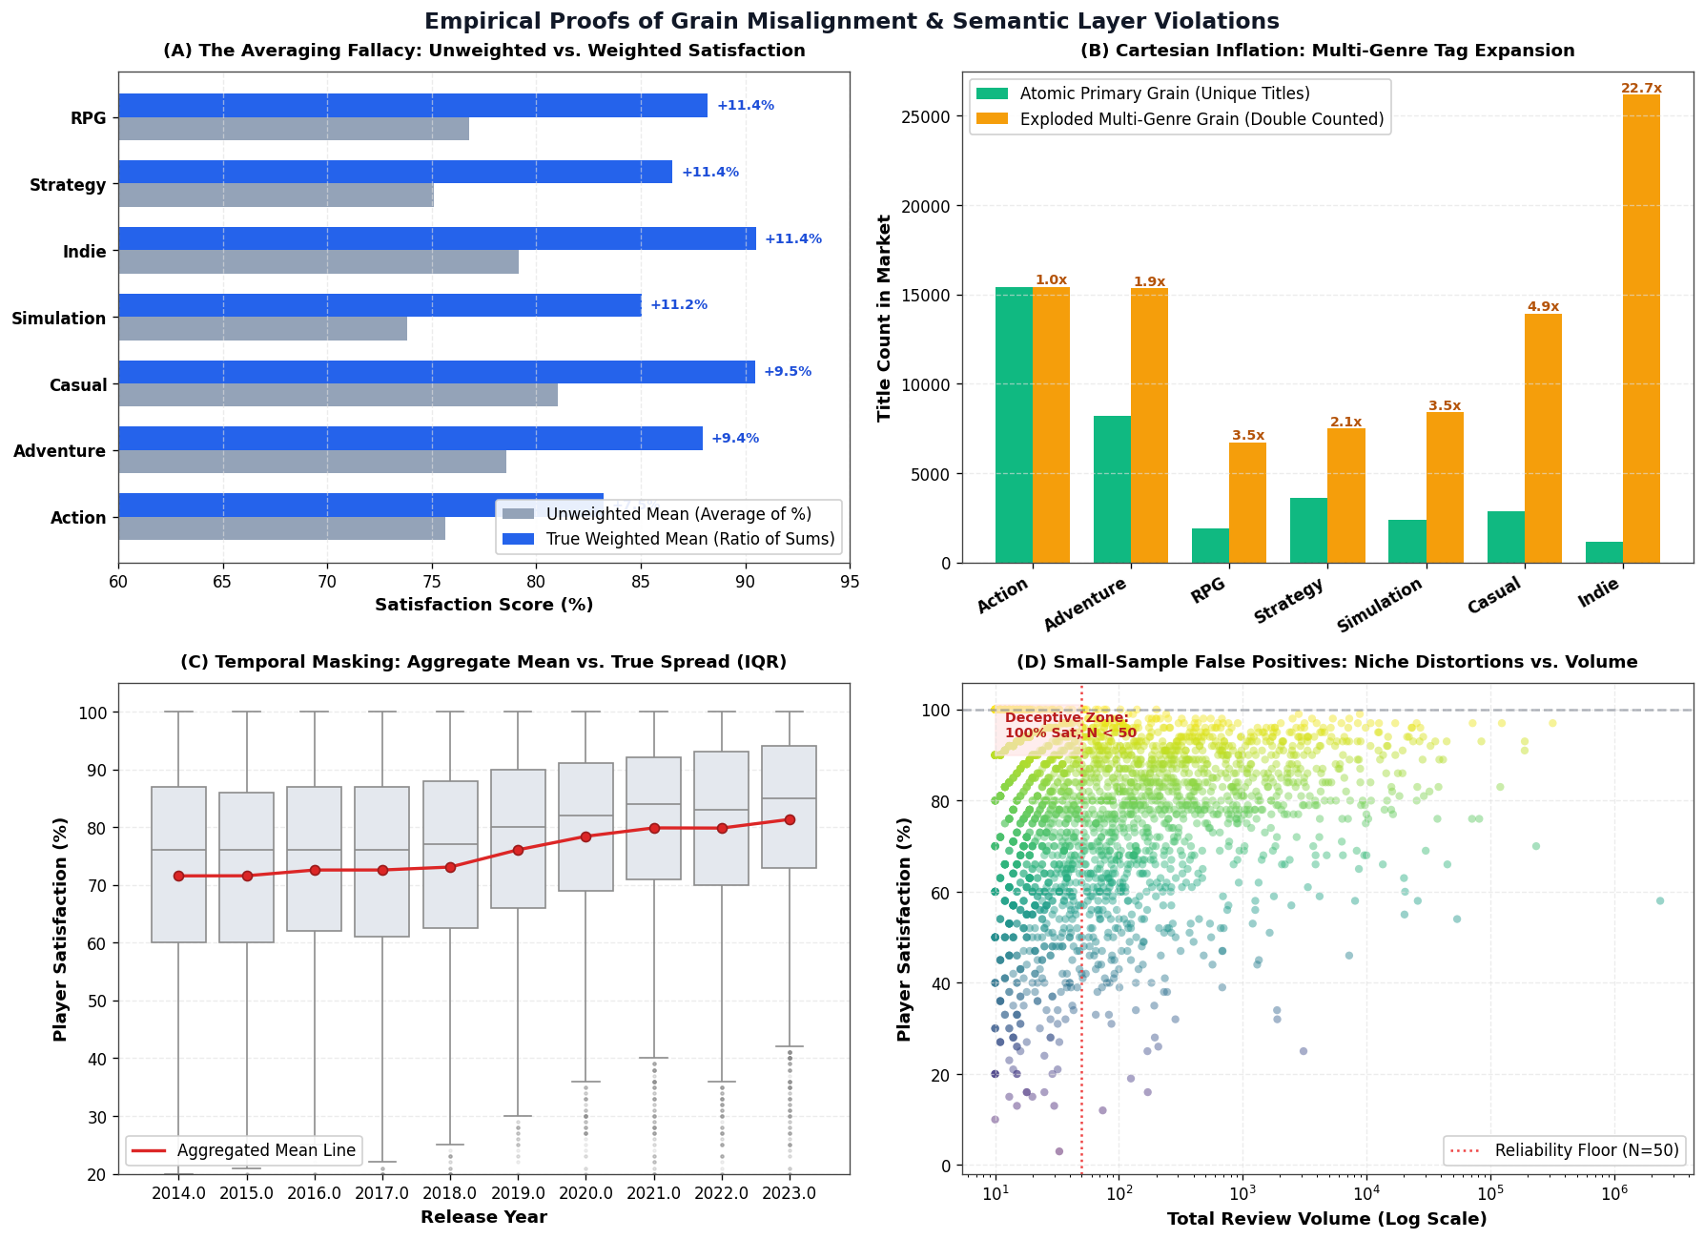
Figure 17 Visual 5
Multi-genre analysis can also create double counting when one title appears under Action, RPG and Indie and its review volume is repeated across all three categories. Bridge structures and distinct-count measures are therefore required. Temporal aggregation may similarly conceal within-year variation, making annual medians appear more stable than the underlying distribution. Small samples create further uncertainty because 100% satisfaction from 10 reviews is less robust than a similar result based on thousands. Finally, reducing written reviews to a single sentiment score can suppress causes such as performance, pricing or gameplay concerns (Valve Corporation, n.d.) Strategic summaries should therefore remain traceable to underlying evidence.

8. Conclusion
The Steam ecosystem demonstrates that multi-grain analysis depends on maintaining semantic consistency across data sources. Catalogue records, API outputs, behavioural events and reviews operate at different grains and should therefore be modelled separately. A reliable architecture preserves source provenance, standardises atomic facts, defines reusable measures and aggregates data into governed KPIs. Many-to-many genres require bridge structures, cumulative measures need time-aware aggregation, and ratio metrics require explicit weighting rules. Visualisation should then reflect the analytical grain, using detailed views for atomic data and simpler summaries for strategic analysis. Misalignment between grain, aggregation and visual form can lead to double counting, unstable comparisons and misleading trends, making clear semantic definitions essential for reliable business interpretation.

Task 3 - Designing Idiomatic, Multi-Perspective Dashboards

1. Introduction
Dashboard design should align with its analytical purpose. Exploratory dashboards support filtering, comparison and hypothesis development, whereas explanatory dashboards guide attention towards selected findings through structured sequencing and annotation (Shao, 2024). This task applies both approaches to the Steam digital marketplace to examine how different visual strategies support analysis and communication.
The Steam dataset is suitable because it combines temporal, categorical, quantitative, network and spatial dimensions, including release year, genre, publisher, platform, price, ratings, review volume and studio location (Huynh, n.d.). These dimensions allow contrasting visual idioms to be evaluated within the same business context. The dashboards address a key strategic issue: apparent popularity does not necessarily indicate commercial value, as catalogue size, review percentage and category scale may conceal differences in evidence strength, market concentration and product performance.

2. Dataset and Analytical Structure
The analytical model uses game-level records containing release year, genre, price, positivity and review volume. These variables support temporal, categorical, quantitative, network and spatial analysis. The exploratory dashboard applies filters for 2015-2024, the genres Action, Adventure, RPG, Strategy, Simulation, Casual and Indie, a maximum price of $60, and a minimum review threshold of 20.
Under this configuration, the dashboard reports 27,158 titles, a $4.20 median price, 81.0% review positivity, and 69,354,551 total reviews. These KPIs are recalculated according to the active filter state, ensuring consistency between summary indicators and detailed views. Review positivity is calculated using aggregated positive and negative reviews, representing review-weighted sentiment rather than the unweighted average of individual game percentages.

3. Dashboard 1 - Exploratory Explorer

3.1 Analytical Purpose and Interaction Design
The exploratory dashboard is intended to support analyst-led investigation rather than communicate a predetermined conclusion. Its function is to allow users to alter the analytical context, compare patterns and test alternative market conditions.
A sidebar provides the main interaction controls through a release-year range, genre selection, price ceiling and minimum-evidence threshold. These parameters act across the entire dashboard rather than on individual charts in isolation. As a result, KPI values and detailed visualisations respond to the same analytical state.
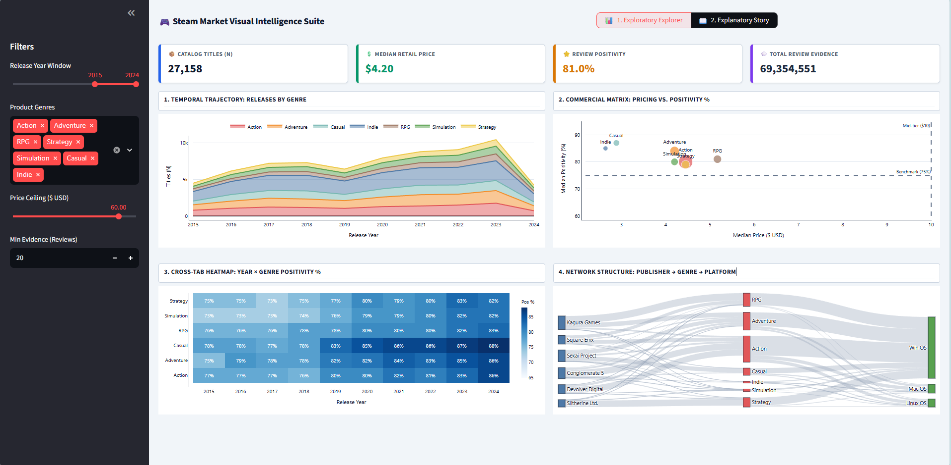
Figure 18 Dashboard 1
This coordinated interaction is important because exploratory analysis depends on maintaining consistency between views. A user changing the minimum evidence threshold, for example, should observe the effect of that decision across all relevant metrics rather than within a single chart. Streamlit's state-management and caching capabilities support this form of coordinated recomputation (Streamlit, 2026) (Streamlit, 2026).

3.2 KPI Summary Layer
Four KPI cards provide an initial summary of the filtered market:
- catalogue titles
- median retail price
- review positivity
- total review evidence.
These indicators provide immediate context on market size, pricing, sentiment and evidence volume before users examine detailed charts. (Hjelle, 2024) show that dashboard structure and information completeness can influence perceived complexity and decision quality. The KPI layer therefore supports orientation while remaining complementary to deeper visual analysis.

3.3 Temporal Trajectory: Releases by Genre
The first exploratory view uses a stacked area chart to examine genre-level release activity over time. This form is appropriate because it represents both overall market growth and the relative contribution of individual genres.
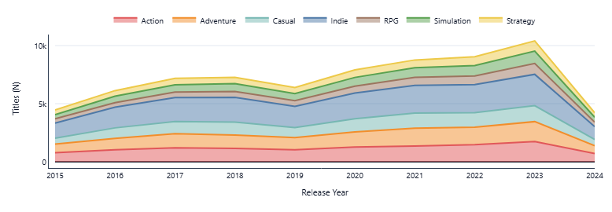
Figure 19 Dashboard 1 - Figure 1

The pattern suggests strong expansion during the late 2010s and early 2020s, followed by a decline in 2024. However, this reduction should be interpreted cautiously because incomplete-year data may partly explain the change.

3.4 Commercial Matrix: Price and Positivity
The second exploratory view uses a bubble scatterplot to compare genre positioning through median price, review positivity and review evidence. Price and positivity are mapped to Cartesian position, supporting relatively accurate quantitative comparison (Cleveland, 1984). Reference lines at 75% positivity and $10 median price provide a consistent frame for interpreting relative market positions rather than fixed performance thresholds.
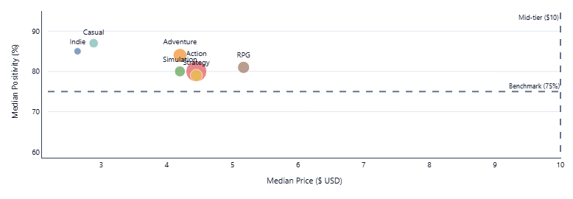
Figure 20 Dashboard 1 - Figure 2

The plot suggests that Casual and Indie combine lower prices with relatively high positivity, while RPG occupies a higher median-price position. Most genres remain below the $10 reference. Bubble size adds review evidence, helping distinguish categories supported by substantial feedback from those with similar positivity but weaker evidence.

3.5 Year × Genre Positivity Heatmap
The third exploratory view uses a heatmap to compare review positivity across genres and release years. Its matrix structure supports rapid identification of temporal and categorical patterns, while direct cell labels reduce reliance on colour estimation alone.
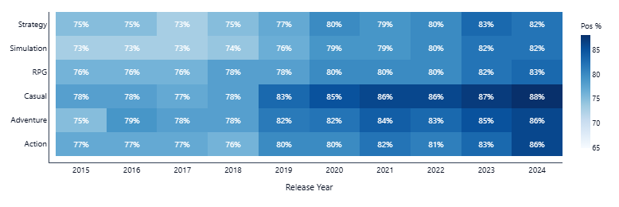
Figure 21 Dashboard 1 - Figure 3
The pattern indicates improving positivity across several genres during the selected period. However, equal-sized cells can represent very different review volumes, so the heatmap should be interpreted as a pattern-detection tool rather than a direct measure of market attractiveness. The minimum-evidence threshold helps reduce this limitation by excluding observations with weak supporting data.

3.6 Publisher Genre Platform Network
The fourth exploratory view uses a Sankey diagram to examine relationships between publishers, genres and operating systems. Rather than emphasising change over time, the chart represents structural connections within the catalogue.

Figure 22 Dashboard 1 - Figure 4
The network suggests that Windows dominates platform support, while Mac and Linux form smaller branches. It also reveals how publishers distribute titles across different genre portfolios. The Sankey idiom is appropriate because link widths represent identifiable category relationships, consistent with Plotly’s source target value structure (Plotly, 2026).

3.7 Filtering and What-if Analysis
The dashboard implements what-if analysis through coordinated filters rather than a separate simulation module. Users can modify the release period, genre selection, price ceiling and evidence threshold and observe corresponding changes across KPIs and charts. These parameter adjustments support conditional comparison, such as testing whether category performance remains consistent after excluding low-evidence titles or restricting the analysis to lower-priced games. The approach therefore enables scenario-based exploration through interactive filtering.

4. Dashboard 2 - Explanatory Story

4.1 Narrative Purpose
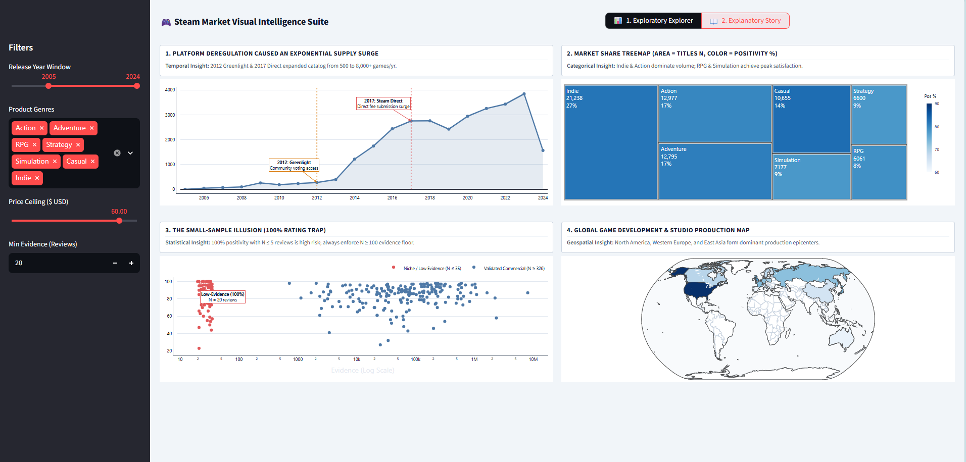
Figure 23 Dashboard 2
The explanatory dashboard is structured to communicate a defined analytical argument rather than support unrestricted exploration. Its narrative emphasises that catalogue growth should not be treated as evidence of market attractiveness without considering market structure, review reliability and production concentration. This reflects explanatory data storytelling, where sequencing, annotation and selective emphasis are used to guide interpretation and improve comprehension of specific analytical findings (Shao, 2024).

4.2 Stage 1 - Supply Expansion Over Time
The first explanatory view uses an annotated line chart to show annual game releases. Markers for Steam Greenlight in 2012 and Steam Direct in 2017 provide contextual links between platform-policy changes and subsequent growth in catalogue supply.
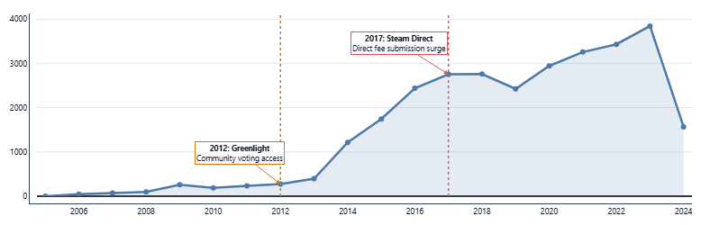
Figure 24 Dashboard 2 - Figure 1

These annotations support interpretation by situating release trends within changes to publishing access. However, the relationship should not be treated as causal evidence, since wider industry developments may also have influenced growth. The chart therefore provides contextual association rather than proof of causation.

4.3 Stage 2 - Market Structure Treemap
The second explanatory stage uses a treemap to summarise catalogue composition by genre. Rectangle area represents category size, while colour provides a separate indication of review positivity. Within the selected data, Indie occupies the largest share, followed by Adventure, Action and Casual.
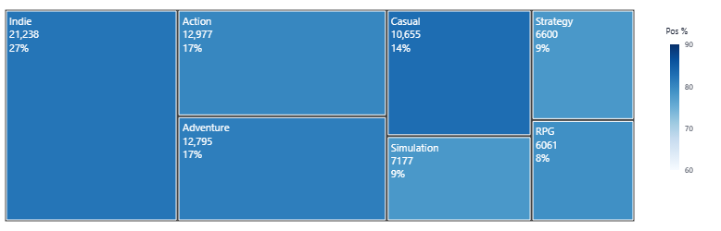
Figure 25 Dashboard 2 - Figure 2

This design distinguishes market presence from user reception. A large genre may represent substantial catalogue activity without achieving the highest positivity, while smaller categories may perform more strongly on reviews. The treemap therefore shows why catalogue share alone is insufficient for judging market attractiveness.

4.4 Stage 3 - Small-Sample Rating Effects
The third explanatory panel evaluates the relationship between review evidence and positivity. A logarithmic scale is used for review counts because evidence volumes vary substantially, allowing low- and high-volume observations to remain comparable.
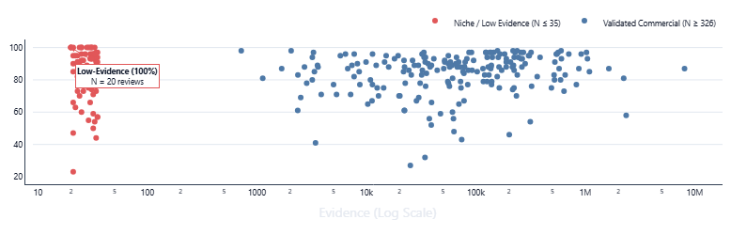
Figure 26Dashboard 2 - Figure 3

The annotated case of 100% positivity from only three reviews illustrates the importance of sample size. Although the percentage is mathematically valid, its evidential strength is much lower than an equivalent rating supported by thousands of reviews.

4.5 Stage 4 - Global Studio Production
The final explanatory panel uses a geographic map to examine studio production by country, highlighting concentration across North America, Western Europe and East Asia. This idiom is appropriate because the analytical focus is spatial distribution. Although a bar chart could support more precise numerical comparison, the map better preserves geographic relationships and regional concentration patterns.
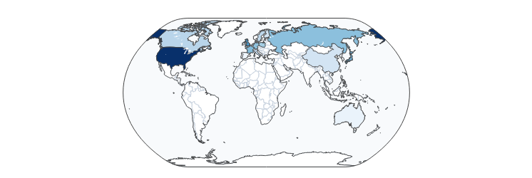
Figure 27 Dashboard 2 - Figure4

5. Critical Evaluation of the Dashboard System
The two dashboards demonstrate how analytical purpose shapes visual design. The exploratory dashboard supports user-led investigation through filters, KPIs and multiple coordinated views, but this flexibility can increase cognitive demand. The explanatory dashboard reduces this complexity through sequencing, annotation and narrative emphasis, although this introduces the risk of framing bias because the author determines which findings receive attention.
Across both dashboards, visual channels are matched to variable meaning: position supports quantitative comparison, hue distinguishes categories, luminance represents ordered magnitude, area provides secondary magnitude cues and annotation adds context. This alignment reduces the risk of misleading interpretation, particularly where inappropriate scales or encodings may distort judgement (Rho, 2024). Effective dashboard design therefore requires a balance between interaction, clarity and authorial guidance rather than treating exploratory or explanatory approaches as inherently superior.

6. Conclusion
The dual-dashboard approach shows that exploratory and explanatory visualisations serve different analytical purposes despite using the same Steam dataset. The exploratory dashboard supports filtering, comparison and hypothesis development across temporal, commercial, categorical and structural dimensions. In contrast, the explanatory dashboard reduces interaction and uses a staged sequence of charts to communicate selected findings concerning catalogue growth, review reliability, market structure and geographic production.
The comparison indicates that dashboard quality depends on the alignment of analytical purpose, semantic meaning, visual encoding and user guidance. Exploratory designs should provide flexibility without creating excessive cognitive demand, while explanatory designs should communicate a clear argument without overstating a selected interpretation. For business decision-making, both approaches are most effective when used together: exploration can identify and test patterns, while explanation can communicate validated findings within an appropriate analytical context.

Task 4 - Future of Visualisation Idioms with Emerging Technologies

1. Introduction
Artificial intelligence and immersive computing are changing how visualisations are produced and interpreted. Traditional visualisation grammar remains relevant because analytical representations still depend on data transformations, marks, scales, channels and coordinates. However, emerging technologies increasingly influence how these components are selected and how users interact with them.
Two developments are particularly important. Generative AI and conversational visualisation allow users to express analytical questions in natural language while systems infer transformations, metrics and visual forms. Immersive analytics, including augmented reality (AR), virtual reality (VR) and related spatial interfaces, extends analysis beyond two-dimensional screens into interactive three-dimensional environments.
These developments suggest a shift from manually specified graphics towards systems that interpret analytical intent, adapt representations and expose how results were produced. The Steam digital marketplace provides a useful context for evaluating these changes.

2. Generative AI and Conversational Visualisation
Generative AI changes visualisation authoring by allowing analysis to begin with an analytical question rather than a predefined chart. In a conventional workflow, analysts select variables, transformations and visual idioms manually. Conversational systems instead attempt to infer these choices from natural-language intent.
For example, an analyst might ask:
“Which Steam genres are becoming more positively reviewed while remaining less saturated than the market average?”
The system must interpret concepts such as positivity and market saturation, identify suitable measures and determine how they should be represented.
Dibia’s LIDA illustrates this transition by combining data summarisation, analytical goal generation and visual specification within an AI-supported workflow (Dibia, 2023). Data Formulator 2 similarly combines graphical controls with natural-language instructions, enabling users to refine both transformations and visual output iteratively (Wang, 2025).
AI-assisted visualisation introduces a semantic stage in which the system interprets analytical intent before generating a suitable representation. Although some graphical decisions may be delegated to AI, effective visualisation still depends on valid transformations, clearly defined metrics and appropriate visual mappings.
Visual idioms may also become more adaptive. Instead of selecting a fixed heatmap, scatterplot or line chart, AI systems may choose or combine idioms according to changes in the analytical question. The future may therefore involve dynamic visual structures rather than fixed chart catalogues.

3. Immersive Analytics, AR/VR and Digital Environments
Immersive analytics extends data analysis into three-dimensional and spatial environments. (Fonnet, 2021) describe it as the use of immersive technologies to support analysis through spatial representation and interaction. However, design principles and evaluation methods remain less established than those used in conventional desktop visualisation. (Friedl-Knirsch, 2024) reviewed 4,678 publications and identified 231 user studies across 209 publications, indicating both growing research interest and considerable variation in evaluation approaches.
Immersive environments extend visual encoding beyond conventional horizontal and vertical position by introducing depth, orientation, distance, viewpoint, gesture, gaze and movement. These channels can support spatial dashboards, navigable networks, immersive timelines and collaborative analytical environments. However, three-dimensional representation is not inherently more effective than two-dimensional visualisation. Its use is most appropriate when spatial relationships or collaboration contribute directly to the analytical task. Digital twins provide a related application by connecting virtual representations with operational data, although not every immersive analytical environment should be classified as a digital twin.

4. Hypothetical Steam Market Analytics Scenario
A future version of the Steam Market Visual Intelligence Suite could combine conversational and immersive analytics. For example, a publisher planning its portfolio in 2032 could ask the system to identify genres with increasing review positivity, below-average release saturation and strong multi-platform support. The AI would interpret these concepts using governed metrics and could represent saturation on the horizontal axis, positivity growth on the vertical axis, review evidence through point size and genre through colour.
The analysis could then be refined through a request such as, “Only show RPG, Strategy and Simulation titles with at least 500 reviews.” This would reduce the need for users to modify SQL queries or manually reconstruct visualisations.
However, AI-generated analysis should maintain visible provenance by showing the selected data fields, transformations, metric definitions and visual encodings used to produce the result. This allows users to evaluate whether the generated conclusion reflects the intended analytical question.
The same semantic model could also support immersive analysis. Publisher–genre–platform relationships could be explored as a navigable spatial network, while global studio production could be represented through an interactive globe with temporal controls. This would be more accurately described as immersive market analytics rather than a digital twin, since the Steam marketplace does not represent a continuously synchronised physical system.

5. Ethical and Cognitive Risks

5.1 Hallucination and Analytical Reliability
Generative AI can produce incorrect analytical outputs while presenting them through convincing language and visual design. (Gu, 2024) show that generated analytical code and explanations may diverge from user intent while remaining plausible. (Wu, 2024) evaluated 19 multimodal large language models, reporting an average chart-question-answering accuracy of 39.8%, while the strongest model achieved 69.17%. These findings indicate that fluent presentation should not be treated as evidence of analytical correctness. AI-generated visualisations therefore require verification of calculations, transformations and interpretations.

5.2 Hidden Semantic Assumptions
Natural-language questions can contain ambiguous business concepts. For example, asking which genre has the “happiest players” could refer to mean game-level positivity, review-weighted positivity, recent positivity or median positivity. Each definition may produce a different result. Analytical systems should therefore expose metric definitions and request clarification when ambiguity could materially change the interpretation.

5.3 Automation Bias
Greater reliance on AI may reduce users’ willingness to examine underlying assumptions, particularly when generated outputs appear authoritative. A more appropriate approach is human-AI co-analysis, where AI reduces technical effort while important metrics, transformations and decisions remain transparent and subject to human review.

5.4 Immersive Bias and Privacy
Immersive environments introduce additional perceptual risks because proximity, scale, viewpoint and occlusion can influence perceived importance independently of statistical value. Photorealistic representations may also create unwarranted confidence in uncertain results. In addition, immersive systems can collect gaze, gesture, movement and voice data, creating privacy concerns. Effective governance should therefore address both analytical data and behavioural information generated through user interaction.

6. Evolution of Visualisation Grammar and Idioms (2026-2036)
Four developments are likely to influence visualisation over the next decade. First, visualisation grammar may shift from predefined graphical marks towards analytical intent, allowing users to describe what they want to understand while AI proposes suitable transformations and visual mappings.
Second, visual idioms may become more adaptive. Systems could move between heatmaps, temporal charts and network views as the analytical question changes.
Third, automation will increase the importance of provenance-aware visualisation. AI-generated outputs should retain clear information about their data sources, transformations, metric definitions, models and visual encodings so that users can verify how conclusions were produced.
Fourth, visualisation is likely to become increasingly cross-reality, with the same governed semantic model supporting conventional dashboards, conversational analysis, AR overlays and immersive environments.
More advanced systems may also detect anomalies, propose hypotheses and generate supporting evidence. As analytical autonomy increases, however, clearer boundaries will be required between automated assistance and accountable human judgement.

7. Conclusion
Generative AI and immersive technologies are extending visualisation by changing how analytical intent is translated into visual form. Conversational AI can reduce technical barriers by allowing users to begin with natural-language questions, although hallucination, ambiguous metric definitions and automation bias remain important concerns.
Immersive analytics introduces spatial and interactive capabilities that may support structural reasoning and collaboration, but it can also create perspective distortion, false realism and privacy risks.
Future visualisation is therefore likely to develop through adaptive systems that combine conversational interfaces, semantic models, automated visual composition and immersive environments. As these systems gain greater analytical autonomy, transparency, provenance and governance will become increasingly important. The central requirement is that AI should expand analytical capability while preserving human accountability for interpretation and decision-making.

Conclusion
This report shows that effective data visualization depends on aligning data structure, visual grammar, idioms, and decision context. The Steam and earthquake analyses demonstrated how different encodings can change interpretation, while semantic layering helped prevent misleading aggregation and metric errors. The exploratory and explanatory dashboards showed how interaction and storytelling can support different analytical needs. Emerging technologies such as generative AI and immersive AR/VR may further transform visualization, but they also introduce risks related to bias, transparency, and reliability. Overall, successful visualization should combine accurate data, appropriate visual design, and responsible analytical interpretation.

References
Cleveland, W. a. M. R., 1984. ‘Graphical perception: Theory, experimentation, and application to the development of graphical methods’, Journal of the American Statistical Association, 79(387), pp. 531–554.. [Online]
Available at: https://faculty.washington.edu/aragon/classes/hcde511/s12/readings/cleveland84.pdf
[Accessed 28 08 2026].
Dibia, V., 2023. LIDA: A tool for automatic generation of grammar-agnostic visualizations and infographics using large language models’, Proceedings of the 61st Annual Meeting of the Association for Computational Linguistics: System Demonstrations, pp. 113–126.. [Online]
Available at: https://aclanthology.org/2023.acl-demo.11.pdf
[Accessed 29 08 2026].
Fonnet, A. a. P. Y., 2021. Survey of immersive analytics’, IEEE Transactions on Visualization and Computer Graphics, 27(3), pp. 2101–2122. [Online]
Available at: https://pubmed.ncbi.nlm.nih.gov/31352344/
[Accessed 29 08 2026].
Friedl-Knirsch, J. P. F. P. S. S. C. A. C. a. R. D., 2024. A systematic literature review of user evaluation in immersive analytics. [Online]
Available at: https://onlinelibrary.wiley.com/doi/10.1111/cgf.15111
[Accessed 29 08 2026].
Gu, K. S. R. A. T. W. C. a. D. S., 2024. How do analysts understand and verify AI-assisted data analyses?’, Proceedings of the 2024 CHI Conference on Human Factors in Computing Systems.. [Online]
Available at: https://arxiv.org/pdf/2309.10947
[Accessed 30 08 2026].
Hjelle, S. M. P. A. N. a. P. V., 2024. Organizational decision making and analytics: An experimental study on dashboard visualizations. [Online]
Available at: https://www.sciencedirect.com/science/article/pii/S0378720624000934
[Accessed 25 08 2026].
Hjelle, S. M. P. A. N. a. P. V., 2024. sciencedirect. [Online]
Available at: https://www.sciencedirect.com/science/article/pii/S0378720624000934
[Accessed 18 08 2026].
Huynh, K., n.d. kaggle. [Online]
Available at: https://www.kaggle.com/datasets/kevinhuynh207/steam-dataset-analysis
[Accessed 19 08 2026].
Mexwell, n.d. kaggle. [Online]
Available at: https://www.kaggle.com/datasets/mexwell/major-earthquakes-6
[Accessed 20 08 2026].
microsoft, 2024. Understand star schema and the importance for Power BI. Microsoft Learn.. [Online]
Available at: https://learn.microsoft.com/en-us/power-bi/guidance/star-schema
[Accessed 24 08 2024].
Microsoft, 2025. Many-to-many relationship guidance. Microsoft Learn.. [Online]
Available at: https://learn.microsoft.com/en-us/power-bi/guidance/relationships-many-to-many
[Accessed 24 008 2026].
Microsoft, 2026. Semantic models in Power BI. Microsoft Learn.. [Online]
Available at: https://learn.microsoft.com/en-us/power-bi/connect-data/semantic-models-third-party
[Accessed 24 08 2026].
Munzner, T., 2014. routledge. [Online]
Available at: https://www.routledge.com/Visualization-Analysis-and-Design/Munzner/p/book/9781466508910
[Accessed 20 08 2026].
Pedersen, T. J. C. a. D. C., 2001. ‘A foundation for capturing and querying complex multidimensional data. [Online]
Available at: https://www.sciencedirect.com/science/article/abs/pii/S0306437901000230
[Accessed 24 08 2026].
Plotly, 2026. Sankey Diagram in Python. Plotly Documentation.. [Online]
Available at: https://plotly.com/python/sankey-diagram
[Accessed 28 08 2026].
Rho, J. R. M. B. S. L. R. M. J. W. A. a. Z. J., 2024. escholarship. [Online]
Available at: https://escholarship.org/uc/item/0kk6b4cn
[Accessed 21 08 2026].
Rho, J. R. M. B. S. L. R. M. J. W. A. a. Z. J., 2024. Various misleading visual features in misleading graphs: Do they truly deceive us?’, Proceedings of the 46th Annual Meeting of the Cognitive Science Society, pp. 2219–2225. [Online]
Available at: https://escholarship.org/uc/item/0kk6b4cn
[Accessed 28 08 2026].
Satyanarayan, A. M. D. W. K. a. H. J., 2017. ieeexplore. [Online]
Available at: https://ieeexplore.ieee.org/document/7539624
[Accessed 22 08 2026].
Shao, H. M.-M. R. E. V. Y. L. a. G. D., 2024. Data storytelling in data visualisation: Does it enhance the efficiency and effectiveness of information retrieval and insights comprehension?’, Proceedings of the 2024 CHI Conference on Human Factors in Computing Systems, Article 195, pp. 1–21.. [Online]
Available at: https://arxiv.org/abs/2402.12634
[Accessed 28 08 2026].
Soto, A. S. M. a. S. K., 2023. springer. [Online]
Available at: https://link.springer.com/article/10.1186/s41235-023-00482-1
[Accessed 22 08 2026].
Streamlit, 2026. st.cache_data. Streamlit Documentation.. [Online]
Available at: https://docs.streamlit.io/develop/api-reference/caching-and-state/st.cache_data
[Accessed 28 08 2026].
Streamlit, 2026. st.session_state. Streamlit Documentation.. [Online]
Available at: https://docs.streamlit.io/develop/api-reference/caching-and-state/st.session_state
[Accessed 28 08 2026].
U.S. Geological Survey (USGS), 2026. Earthquake Magnitude, Energy Release, and Shaking Intensity. [Online]
Available at: https://www.usgs.gov/programs/earthquake-hazards/earthquake-magnitude-energy-release-and-shaking-intensity
[Accessed 22 08 2026].
U.S. Geological Survey (USGS), 2026. NSS Comprehensive Earthquake Catalog (ComCat) Documentation. [Online]
Available at: https://earthquake.usgs.gov/data/comcat
[Accessed 22 08+ 2026].
Valve Corporation, n.d. User Reviews – Get List. Steamworks Documentation. [Online]
Available at: https://partner.steamgames.com/doc/store/getreviews?l=english
[Accessed 24 08 2026].
Valve Corporation, n.d. User Reviews. Steamworks Documentation.. [Online]
Available at: https://partner.steamgames.com/doc/store/reviews
[Accessed 24 08 2026].
Vega-Lite, 2026. Vega-Lite Documentation: Encoding, Marks and Faceting.. [Online]
Available at: https://vega.github.io/vega-lite/docs/encoding.html
[Accessed 22 08 2026].
Wang, C. L. B. D. S. M. D. a. G. J., 2025. Data Formulator 2: Iterative creation of data visualizations, with AI transforming data along the way’, Proceedings of the 2025 CHI Conference on Human Factors in Computing Systems.. [Online]
Available at: https://www.microsoft.com/en-us/research/publication/data-formulator-2-iteratively-creating-rich-visualizations-with-ai
[Accessed 29 08 2026].
Wankhade, M. R. A. a. K. C., 2022. A survey on sentiment analysis methods, applications, and challenges. [Online]
Available at: https://link.springer.com/article/10.1007/s10462-022-10144-1
[Accessed 24 08 2026].
Wickham, H., 2010. A layered grammar of graphics’, Journal of Computational and Graphical Statistics. [Online]
Available at: https://www.tandfonline.com/doi/abs/10.1198/jcgs.2009.07098
[Accessed 23 08 2026].
Wilkinson, L., 2005. The Grammar of Graphics. 2nd edn. New York: Springer.. [Online]
Available at: https://link.springer.com/book/10.1007/0-387-28695-0
[Accessed 23 08 2026].
William S., C. & Robert , M., 1984. faculty.washington.edu. [Online]
Available at: https://faculty.washington.edu/aragon/classes/hcde511/s12/readings/cleveland84.pdf
[Accessed 19 08 2026].
Wu, Y. Y. L. S. L. W. Y. T. N. a. L. Y., 2024. ChartInsights: Evaluating multimodal large language models for low-level chart question answering. [Online]
Available at: https://aclanthology.org/2024.findings-emnlp.710.pdf
[Accessed 30 08 2026].




